The Student Experience in Brief:
Dakota State University



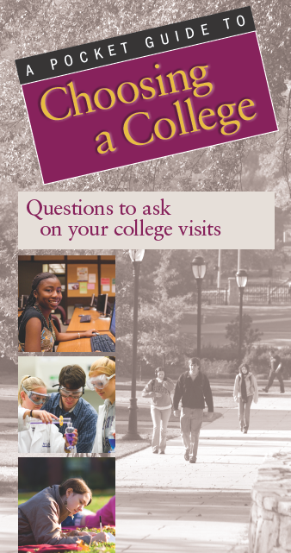
Each year the National Survey of Student Engagement (NSSE) asks students at hundreds of colleges and universities to reflect on the time they devote to various learning activities. The topics explored are linked to previous research on student success in college.

Results from NSSE can provide prospective students with insights into how they might learn and develop at a given college. To help in the college exploration process, NSSE developed A Pocket Guide to Choosing a College to provide students and their families key questions to ask during campus visits.

The following responses were provided by 201 Dakota State students on the 2012 NSSE survey.

Academic Challenge

To what degree is studying and spending time on academic work emphasized?
68% of first-year (FY) students feel that this institution places substantial¹ emphasis on academics.

Do faculty hold students to high standards?
54% of FY students frequently² work harder than they thought they could to meet faculty expectations.

How much time do students spend on homework each week?
31% of FY students spend more than 15 hours per week preparing for class; 25% spend 5 hours or less.

What types of thinking does coursework require?
The percentages of FY students who report substantial emphasis on the following activities:
Memorizing facts, ideas, or methods: 56%
Analyzing basic elements of an idea or theory: 70%
Synthesizing and organizing ideas: 54%
Making judgments about value of information: 60%
Applying theories or concepts: 69%

How much writing is expected?
12% of FY students write more than four papers between 5 and 19 pages and 14% write at least one paper of at least 20 pages.

How much reading is expected during the school year?
14% of FY students read more than 10 assigned books or packs of course readings; 41% read fewer than 5.

Do exams require students to do their best work?
45% of FY students report that their exams strongly challenge³ them to do their best work.

Active Learning

How often are topics from class discussed outside of the classroom?
41% of FY students frequently discuss readings or ideas from courses outside of class.

Do students work together on projects – inside and outside of class?
46% of FY students frequently work with other students on projects in class, and 41% frequently work with peers on assignments outside of class.

How often do students make class presentations?
27% of FY students frequently make presentations in class.

How many students participate in community-based projects as part of their courses?
6% of FY students frequently participate in service-learning or community-based projects; 71% never take part in such activities.

How many students apply their classroom learning to real life through internships or off-campus field experiences?
By spring of their senior year, 50% of students participate in some form of practicum, internship, field experience, co-op, or clinical assignment.

Do students have opportunities to tutor or teach other students?
11% of seniors frequently assist their fellow students by tutoring or teaching.

Student-Faculty Interaction

Are faculty members accessible and supportive?
78% of FY students say their faculty are available, helpful and sympathetic.⁴

How many students work on research projects with faculty?
By spring of their senior year, 15% of students do research with a faculty member.

IPEDS=219082
Do students receive prompt feedback on academic performance?
58% of FY students frequently get prompt verbal or written feedback from faculty members.

How often do students talk with advisors or faculty members about their career plans?
79% of seniors at least occasionally⁵ discuss career plans with faculty; 21% never talk with faculty members about career plans.

Do students and faculty members work together on committees and projects outside of course work?
52% of FY students at least occasionally spend time with faculty members on activities other than coursework.

Enriching Educational Experiences

What types of distinctive programs are offered?
During their first year, 6% of students participate in a learning community. By spring of their senior year, 13% of students have done independent study.

How often do students interact with peers who have different viewpoints than their own?
37% of FY students frequently have serious conversations with students who are different from themselves in terms of their religious, political, or personal beliefs.

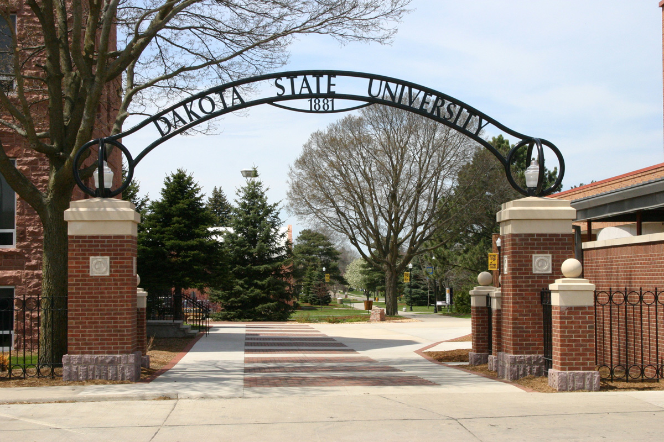

INSERT YOUR CAMPUS PHOTO HERE

How often do students interact with peers from different racial or ethnic backgrounds?
32% of FY students frequently have serious conversations with those of a different race or ethnicity.
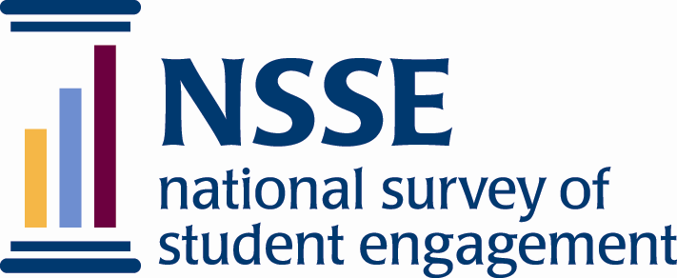
How many students study in other countries?
By their senior year, 6% of students have studied abroad.

Do students participate in activities that enhance their spirituality?
23% of FY students frequently engage in spiritually enhancing activities such as worship, meditation, or prayer.

What percentage of students participate in community service?
By the time they are seniors, 52% of students participate in community service or volunteer work.

Supportive Campus Environment

How well do students get along with other students?
70% of FY students report that their peers are friendly, supportive, and give them a sense of belonging.⁶

Are students satisfied with their overall educational experience?
77% of FY students rate their experience as good or excellent; 79% of seniors would choose this school again if they could start their college career over.

How much time do students devote to co-curricular activities?
25% of FY students spend at least 5 hours a week participating in co-curricular activities; 40% do not participate in such activities.

How well do students get along with administrators and staff?
54% of FY students find the administrative personnel and offices helpful, considerate, and flexible.⁷

How much does the school help students with their academic and social needs?
70% of FY students feel that this institution provides substantial support for their academic success; 41% perceive substantial support for their social needs.

Notes:
- ‘Substantial’ emphasis is defined by combining responses of ‘Very much’ and ‘Quite a bit.’
- ‘Frequently’ is defined by combining responses of ‘Very often’ and ‘Often.’
- ‘Strongly challenge’ is defined by combining responses of ‘5,’ ‘6,’ and ‘7’ on a seven-point scale where 1 is ‘Very little’ and 7 is ‘Very much.’
- ‘Available, helpful, sympathetic’ is defined by combing responses of ‘5,’ ‘6,’ and ‘7’ on a seven-point scale.
- ‘Occasionally’ is defined by combining the responses ‘Very often,’ ‘Often,’ and ‘Sometimes.’
- ‘Friendly, supportive, and sense of belonging’ is defined by combining responses of ‘5,’ ‘6,’ and ‘7’ on a seven-point scale.
- ‘Helpful, considerate, and flexible’ is defined by combining responses of ‘5,’ ‘6,’ and ‘7’ on a seven-point scale.


A Pocket Guide to Choosing a College is available at nsse.iub.edu/html/pocket_guide.cfm

Indiana University
Center for Postsecondary Research
1900 East Tenth Street, Suite 419
Bloomington, IN 47406-7512

Phone: 812-856-5824
Fax: 812-856-5150
Email: nsse@indiana.edu
Web site: nsse.iub.edu IPEDS=219082

