SOUTH DAKOTA BOARD OF REGENTS
ACADEMIC AFFAIRS FORMS

Accelerated Graduate Program Request

Use this form to request an accelerated graduate program and the appropriate required codes from the Enrollment Services Center. After the university President approves the proposal, submit a signed copy to the Executive Director through the system Chief Academic Officer.

UNIVERSITY: | DSU
NAME AND DEGREE (e.g., BA, BS) OF UNDERGRADUATE PROGRAM: | BS Financial Technology
NAME AND DEGREE (e.g., MA, MS, PhD) OF GRADUATE PROGRAM: | MS Analytics & Applied AI

University Approval
To the Board of Regents and the Executive Director: I certify that I have read this proposal, that I believe it to be accurate, and that it has been evaluated and approved as provided by university policy.
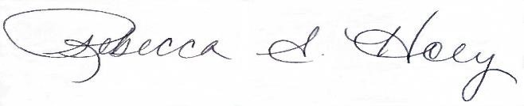 |  | 11/6/2026
Vice President of Academic Affairs or President of the University |  | Date

An accelerated graduate program for the purposes of this guideline is a graduate program at a Regental institution that allows a student to count courses for undergraduate and graduate credit simultaneously. Board Policy 2.4.2 – Course Level, Numbering, and Enrollment in Courses governs the transfer of courses between the undergraduate and graduate program.

Board of Regents Policy 2.2.2.1 – Seamless Transfer of Credit requires the Board of Regents to approve accelerated programs involving the transfer of thirteen (13) or more credits up to a total of twenty-five (25) total transfer credit hours at the accepting institution. In other words, an institution may create an accelerated program of one (1) to twelve (12) hours without Board approval. However, an accelerated program requires the creation of coding by the Enrollment Services Center (ESC) regardless of whether or not the accelerated program is accepting more than twelve (12) credit hours.

- Maximum number of credits allowed to transfer between undergraduate and graduate program:

9 credits

- Is the response to Question 1 more than thirteen (13) credit hours?

Yes ☐  (requires BOR approval) | No ☒  (does not require BOR approval)

- What is the proposed date (day/month/year) the accelerated program would begin?

Spring 2027

- Please provide a brief explanation of the accelerated program, including specific courses eligible for both the undergraduate and graduate program credit.

Graduate Course |  |  |  |  | Undergraduate Course
INFS | 672 | Programming for Analytics | 3 |  | CIS | 372 | Programming for Analytics | 3
INFS | 668 | Predictive Analytics for Decision Making | 3 |  | CIS | 368 | Predictive Analytics | 3
INFS | 676 | Business Intelligence and Visualization | 3 |  | CIS | 474 | Business Intelligence and Big Data | 3

The proposed accelerated program will provide upper-level undergraduate students with the opportunity to complete graduate coursework that can also be applied toward their bachelor’s degree requirements.

