

Virtual Review Timeframe:
March to May 2026

External Reviewer:
Dr. Benjamin Forsyth

Master of Science in Education and Technology

Year Six
Program Self Study

Date 2026

Dean: Dr. David DeJong
Department Chair: Kindra Schneider

TABLE OF CONTENTS
Section 1: Institutional History
Section 2: Program History
Section 3: Program Trends within the Discipline
Section 4: Program Features and Curriculum
Section 5: Program Enrollment, Persistence, Retention, and Graduation
Section 6: Faculty Credentials
Section 7: Academic and Financial Support
Section 8: Facilities and Equipment
Section 9: Student Learning Assessment Plans and Results
Section 10: Alumni Placement & Satisfaction
Section 11: Program Opportunities for Improvement
Appendix A: Student Plan of Study

Section 1: Institutional History

Mission Change
Since 1881, Dakota State University (DSU) has provided challenging academic programs in one of the best educational environments in South Dakota. In 1984, the Legislature of the State of South Dakota (South Dakota Codified Law §13-59-2.2) authorized Dakota State University with the primary purpose of providing instruction in computer management, computer information systems, business, and electronic data processing. DSU has the authority to credential certificates, associate degrees, baccalaureate degrees, master's degrees, and doctoral degrees through formal approval by the South Dakota Board of Regents (SDBOR) and the Higher Learning Commission (HLC), DSU’s institutional accreditor.

Special Focus Institution
The SDBOR has identified DSU as a “special focus” STEM University with an emphasis in computer management, computing information technologies, cybersecurity, and related undergraduate and graduate degrees. DSU’s emerging research and focus on cybersecurity is propelling the workforce, economy, and student experience to protect and advance South Dakota and beyond.

Institutional Mission
DSU's operational mission is to prepare cyber-savvy graduates who are lifelong learners, problem solvers, innovators, and leaders to live lives of positive purpose and consequence.

Institutional Vision
Innovative, entrepreneurial, and resilient since 1881, DSU will continue to rise through short - and long-term success of our students and graduates, increased strength in applied research and athletics, and deep engagement with our stakeholders, in an environment infused with quality improvement.

Institutional Values
- Distinguished and effective teaching
- Integrity
- Clear communication
- Innovation
- Inclusion
- Quality

Institutional Accreditation
Dakota State University is accredited by the Higher Learning Commission (HLC), founded in 1895, and is one of several institutional accreditors in the United States. HLC accreditation indicates that DSU has the standards, processes, and assurance that it delivers quality educational experiences. DSU must meet core components within the four HLC Criteria for Accreditation. The University completes periodic reviews for reaffirmation of accreditation through HLC's Open Pathway, a ten-year cycle with an assurance review in year four and a comprehensive evaluation in year ten. The Open Pathway also includes an improvement component, the Quality Initiative, between years four and ten, that provides DSU the opportunity to pursue improvement projects that meet institutional needs. The institution's most recent comprehensive reaffirmation visit in October 2018 resulted in a positive review without any requirement for monitoring reports. In October 2022, DSU also met all core components during its mid-cycle assurance review.

Section 2: Program History

- When, how, and why the program was developed:

Dakota State University received approval from the South Dakota Board of Regents in September 1998 to develop and offer the Master of Science in Educational Technology (MSET). In early 1999, the Board commissioned Dr. David Moursund (University of Oregon) to conduct an external review of the proposal and provide recommendations to strengthen the program prior to full implementation.

Dakota State University developed the program in response to growing demand for advanced preparation in educational technology and refined it through this external review process. Key modifications included increasing elective credits to provide greater flexibility, adding a required 3-credit leadership course to prepare students to lead systemic technological change, and reducing the number of specifically required courses. To support high-quality course development - particularly for distance delivery - the university provided faculty release time and summer grants. The review also emphasized strong technology support for online students, leading to expanded services through the Office of Online Education, including technical and instructional design support.

Course delivery began in Fall 1999. Final approval was granted by the North Central Accreditation Association (NCA) on April 26, 2000, and students were formally admitted as degree-seeking candidates beginning in the 2000–2001 academic year.

- Program alignment with DSU’s institutional mission:

The Master of Science in Educational Technology (MSET) program directly supports Dakota State University’s mission to prepare cyber-savvy graduates who are lifelong learners, problem solvers, innovators, and leaders who live lives of positive purpose and consequence. The 30-credit program develops advanced technological fluency through coursework in visual design, instructional design, computer programming, leadership, evaluation, research, STEM, and emerging technologies. This interdisciplinary foundation ensures that graduates are not only proficient users of technology but also critical thinkers who understand how to design, implement, and evaluate technology-rich learning environments.

Throughout the program, students apply their learning in authentic, real-world contexts. These applied experiences strengthen problem-solving skills, foster innovation, and prepare graduates to lead technological change in schools, organizations, and training environments. By combining technical expertise, research-based practice, and leadership development, the MSET program produces graduates who are equipped to make meaningful, positive contributions in the digital age—fully reflecting DSU’s institutional mission.
- Results of last comprehensive program review:

April 30, 2018

External Reviewer:
Lynne McKnight Herr, Ph.D., Department of Teaching, Learning, and Teacher Education, College of Education and Human Sciences at the University of Nebraska-Lincoln

From the External Reviewer:
The previous program review concluded that the MSET program was functioning satisfactorily and meeting a clear need within both the university and the broader community. The program was recognized for its dedicated and qualified faculty, a curriculum consistent with standards in Educational Technology, knowledgeable and employable students, and supportive alumni. The reviewer noted that only minor adjustments were necessary to maintain the program’s solid standing within the university and the field.

Importantly, the review emphasized that the MSET program had already surpassed being merely “good” and, with continued attention, investment, and strategic care, had the potential to become one of the region’s outstanding programs. At the same time, the reviewer identified declining enrollment and the dynamic nature of the Educational Technology field as factors necessitating ongoing program evaluation and strengthened recruitment efforts.

Summary of Reviewer Recommendations:
The reviewer offered six recommendations aimed at strengthening the MSET program and enhancing its appeal to local and regional applicants:
- Develop clearly defined concentrations within the MSET program (e.g., technology-infused pedagogy, technology leadership and support, and coding/STEAM education) to improve recruitment and better target specific educator audiences.
- Align curriculum with industry-recognized credentials by researching certifications and badging programs from leading educational technology companies (e.g., Google, Apple, Microsoft) and incorporating relevant elements into coursework.
- Implement annual faculty retreats focused on continuous improvement, long-term planning, and enrollment growth. These retreats should include review of educational forecasting resources and result in shared outcomes with students and administration.
- Pursue funding to sustain reduced-tuition summer offerings as a recruitment strategy, highlighting cost-effective pathways such as South Dakota’s reduced tuition program.
- Invest in flexible learning spaces and updated technologies to model innovative instructional environments aligned with program goals.
- Position the MSET program as a campus center for teaching excellence, leveraging its expertise to enhance digital pedagogy across DSU and potentially justify additional faculty and technical support.
- Changes made to the academic program since the last review: 2018

Reviewer Recommendation from 2018 Report | Change Made Since Recommendation
Develop clearly defined concentrations | Previously, the program’s autonomy was limited due to a partnership with USD for core course delivery. Following the conclusion of this partnership in 2025, the program underwent a comprehensive curriculum review and revision. This independence allowed us to restructure the degree and establish three distinct specializations tailored to current workforce demands: Educational Technology, Computer Science and Cyber, and Literacy Instructional Coaching.
Align curriculum with industry-recognized credentials | To ensure graduates are equipped with market-relevant skills, the program integrated the Google Certified Educator credentialing system into the curriculum. This alignment is strategically significant, as the majority of K-12 districts in our region primarily utilize Google Workspace for Education.  Faculty have embedded the preparation and assessment components for these credentials into two courses. Upon successful completion of the corresponding Google exams, students earn their Level I and Level II Educator certifications. This integration bridges the gap between academic theory and technical proficiency, providing students with verified, industry-standard competencies.
Implement annual faculty retreats focused on continuous improvement | In lieu of a single annual retreat, the program maintains a continuous cycle of faculty engagement to ensure alignment with enrollment goals and industry trends. This is achieved through three primary mechanisms:  - Strategic Briefings: The Program Coordinator issues regular updates on enrollment data and marketing initiatives, soliciting faculty feedback to guide program direction.  - Data-Driven Consultation: Periodic faculty surveys are utilized to systematically gather input on curriculum health and long-term planning.  - Collaborative Meetings: Faculty meet throughout the academic year to review educational forecasting and coordinate shared outcomes for students and administration.
Pursue funding to sustain reduced-tuition summer offerings | The college has successfully secured multiple grant sources to subsidize summer coursework and workshops, significantly reducing tuition costs for participants:  - DSU Teach Camp: Funded by various grants, this annual workshop allows students to earn one graduate elective credit at a reduced rate of $40 per credit.  - Governor’s Cyber Academy: Funding from this initiative supports a week-long intensive workshop where teachers can earn three graduate elective credits.  Both initiatives have proven to be highly effective recruitment tools, successfully funneling new educators into the full graduate program while maintaining financial accessibility.  In 2023 the State of South Dakota extended their tuition reduction benefit to state employees to include online courses (the previous policy only included on campus courses). With the 50% tuition reduction to K-12 teacher’s, available any term of the academic year, technology coordinators and others affordability of the MSET program increased substantially.
Invest in flexible learning spaces and updated technologies | As an online program, faculty have focused their investments on enhancing the digital learning environment to model innovative instructional practices:  - Interactive Applications: The program invested in Nearpod and other specialized software to transition from passive delivery to highly interactive, synchronous, and asynchronous learning experiences.  - Pedagogical Professional Development: Faculty have dedicated significant time to mastering emerging educational technologies, ensuring that online course design aligns with current industry standards for student engagement.  This dual investment in both software and faculty expertise creates a virtual "flexible space" that mirrors the innovative environments our graduates will lead in their own districts.
Position the MSET program as a campus center for teaching excellence | While the MSET program remains a distinct academic entity, it was instrumental in the 2018 establishment and early leadership of DSU’s Center for Teaching and Learning (CTL):  - Foundational Leadership: The MSET Program Coordinator established the university’s first Center for Teaching and Learning (CTL) and served as its first director from 2018-2023. This included a dedicated budget to hire a full-time instructional designer to support faculty capacity in F2F-online instruction and meet Quality Assurance standards.  - Institutional Training & Governance: MSET faculty continue to drive campus-wide excellence by leading professional development (PD) sessions on digital pedagogy and serving on key committees that shape faculty training across the university.  Through this collaboration, the MSET program has successfully exported its expertise to enhance instructional quality across the entire DSU campus.

Other changes made to the academic program:
Since the last review cycle, the Master of Science in Educational Technology program has undergone several important changes designed to strengthen academic quality, increase program responsiveness, and enhance student learning outcomes.
1. Program Name Revision and Expansion of Specializations
In April 2024, program faculty sought Regental approval to change the name of the program from Master of Science in Educational Technology to Master of Science in Education and Technology. Although subtle, this change reflects an important expansion in the scope of the program, better aligned with DSU’s Advance 2022-2027 Strategic Plan to equip educators with the ability to address modern teaching challenges. The revised program structure allows students to pursue specialized areas of study while maintaining a shared core of foundational coursework.
The program now offers three specializations: Educational Technology, Computer Science and Cyber Education, and Literacy Instructional Coaching. This structure broadens the program’s reach and allows it to respond more effectively to workforce and educator preparation needs while preserving the program’s emphasis on technology-supported teaching and learning.
2. Conclusion of Partnership with the University of South Dakota
Also in April 2024, the program concluded its formal partnership with the University of South Dakota due to significant enrollment differences in shared courses and shifting perceptions of the modern instructional technology capacity needs of the K-12 community. This transition provided the opportunity to assume full ownership and oversight of the curriculum. With greater institutional control, faculty conducted a comprehensive review of all courses to ensure alignment with program learning outcomes, industry standards, and evolving professional expectations in educational technology.

As part of this review process, faculty revised courses and added new courses to better reflect current practices and emerging needs within the field. The result is a more cohesive, forward-looking curriculum that is fully aligned with the mission and strategic priorities of the institution while maintaining rigor and relevance.

3. New Faculty Appointments and Instructional Perspectives
Curricular revisions necessitated adjustments in faculty assignments, resulting in new faculty teaching within the program. These faculty members bring diverse professional experiences and scholarly expertise that complement the updated curriculum. Their involvement has introduced fresh perspectives, innovative instructional strategies, and expanded areas of specialization within the program.

The addition of new faculty has strengthened course delivery, enriched student engagement, and ensured that instruction reflects current research and practice in education and technology. This transition has also supported continuous program improvement through collaborative curriculum development and assessment practices.

4. Emphasis on Emerging Trends in Educational Technology
Recognizing the rapidly evolving nature of educational technology, the program has intentionally increased its focus on emerging trends. Preparing graduates to lead and innovate in dynamic educational environments requires ongoing integration of new tools, methodologies, and conceptual frameworks.

To support this goal, the program has offered summer workshops addressing high-impact topics such as computational thinking, artificial intelligence, cybersecurity, and related emerging areas. These workshops provide both current students and practicing professionals with timely, applied learning opportunities.

Additionally, the program developed a dedicated Emerging Technologies course. This course is designed to be adaptable, allowing faculty to continuously update content in response to technological advancements and shifting educational landscapes. This structure ensures that students remain informed about cutting-edge developments and are prepared to critically evaluate and implement new technologies in educational settings.

6. Revisions to the Culminating Portfolio Process
The program has made targeted improvements to the culminating portfolio process by providing clearer guidance, structured checkpoints, and more consistent faculty feedback throughout development. Students are now encouraged to engage in more intentional reflection on their learning and professional growth, strengthening their ability to articulate how coursework has contributed to their practice in educational technology.

In addition, the portfolio has recently been incorporated into a designated capstone course to promote consistency in expectations, timelines, and faculty oversight. These refinements enhance student support while maintaining the overall purpose of the portfolio as a demonstration of program learning outcomes.

Program History Strengths:

- Dedicated core faculty are student-centered and committed to fostering student success through accessible communication, thoughtful feedback, and ongoing support.

- The program is supported by university administration, reflecting institutional commitment to graduate education and continued program development.

- Faculty maintain active engagement in the field of educational technology by participating in regional and national conferences, professional organizations, and ongoing scholarly work.

- The program benefits from experienced faculty, several of whom have completed online coursework themselves. This experience informs their instructional design practices and strengthens the quality, organization, and engagement of online course delivery.

- The curriculum reflects current and cutting-edge developments in educational technology, including emerging tools, methodologies, and research-based practices.

- Courses incorporate authentic, project-based learning experiences that allow students to apply theoretical concepts to real-world educational contexts.

- The program emphasizes applied, hands-on learning experiences that prepare graduates to implement and lead technology initiatives in educational settings.

Section 3: Program Trends within the Discipline

- International, national, regional, and state trends in the academic program:
The field of educational technology is dynamic and continually shaped by international advancements, national initiatives, and regional and state-level educational priorities. Below is an explanation of these international, national, and regional trends.

International Trends in Educational Technology:
Internationally, educational technology is being shaped by rapid advancements in digital innovation, artificial intelligence, and expanded access to online and blended learning environments. Institutions and organizations across the globe are investing in AI-driven tools, learning analytics, adaptive platforms, and immersive technologies such as virtual and augmented reality to personalize learning and increase engagement. At the same time, global conversations emphasize digital equity, accessibility, and ethical technology use, particularly as nations work to reduce disparities in broadband access, device availability, and digital literacy. These trends reinforce the importance of preparing educational technology professionals who can thoughtfully evaluate and implement emerging tools while addressing issues of privacy, data security, and responsible innovation.

In addition, initiatives and global digital skills agendas highlight the growing expectation that educators and instructional leaders possess strong technological and pedagogical competencies. Frameworks such as the International Society for Technology in Education (ISTE) Standards emphasize the role of educators as learners, leaders, citizens, collaborators, designers, facilitators, and analysts who leverage technology to create meaningful learning experiences and improve educational outcomes. There is increasing emphasis on computational thinking, digital citizenship, cybersecurity awareness, and workforce readiness in a technology-driven economy. For a master’s program in educational technology, these global trends underscore the need to equip graduates with both theoretical foundations and applied skills that enable them to design effective digital learning environments, lead technology integration efforts, align with established professional standards, and adapt to continuous technological change in diverse educational contexts.

National Trends in Educational Technology (United States):
At the national level, educational technology trends are influenced by federal guidance and professional standards that emphasize digital equity, effective technology integration, and learner-centered design. The 2024 National Educational Technology Plan from the U.S. Department of Education highlights the need to close three key digital divides: the digital access divide, the digital design divide, and the digital use divide. These divides address inequities in access to connectivity and devices, the professional capacity of educators to design technology-enabled learning experiences, and the extent to which students engage in active, creative, and critical uses of technology for learning. The plan emphasizes leveraging technology to support meaningful, collaborative learning experiences and equitable opportunities for all students. These priorities underscore the expectation that educational technology leaders are prepared not only to implement digital tools, but to strategically design and lead technology integration that improves teaching, learning, and student outcomes.

Professional organizations such as the International Society for Technology in Education (ISTE) further shape national expectations through widely adopted standards for educators, students, instructional coaches, and education leaders. The ISTE Standards emphasize empowered learning, digital citizenship, knowledge construction, innovative design, and computational thinking. Together, these national initiatives reinforce the need for graduate-level preparation that develops leadership capacity, ethical decision-making, instructional design expertise, and the ability to evaluate and implement emerging technologies in meaningful and sustainable ways across educational settings.

Regional Trends (Midwest U.S./Great Plains):
At the regional level, states in the Upper Midwest are increasingly integrating educational technology into policy development, digital learning infrastructure, and educator professional development. State education agencies continue to prioritize issues such as digital access, broadband connectivity, cybersecurity, and sustainable technology systems. These priorities reflect broader national trends identified in reports such as the SETDA State EdTech Trends Report. These efforts focus on supporting districts in developing reliable digital infrastructure and promoting equitable and effective uses of technology for teaching and learning.
Within the region, collaborative initiatives and data-informed planning efforts are also emerging. For example, Nebraska uses Future Ready District Technology Profiles, a statewide data collection tool that gathers information about district technology infrastructure and digital learning practices to inform planning and support needs. Minnesota’s shared resource networks, such as Minitex, demonstrate how statewide collaboration can expand access to research databases, digital materials, and professional resources across educational institutions. In addition, interstate organizations such as the Midwestern Higher Education Compact (MHEC) support collaboration among Midwestern states through policy research, shared purchasing programs, and initiatives related to technology, workforce development, and innovation in higher education.
South Dakota Trends in Educational Technology:
At the state level, South Dakota continues to prioritize broadband expansion and digital infrastructure, particularly in rural areas, to support equitable access to online and blended learning environments. The South Dakota Department of Education promotes technology integration through statewide planning efforts and alignment with ISTE Standards, guiding districts in the effective use of digital tools for instruction and student learning.

Additionally, the state emphasizes professional development in instructional technology, digital literacy, and emerging areas such as artificial intelligence and cybersecurity. Ongoing efforts to strengthen one-to-one device access, support educator training, and prepare students with future-ready skills reflect South Dakota’s commitment to advancing technology integration across educational settings.

- How trends influence curricular and instructional decisions:
International, national, regional, and state trends in educational technology inform ongoing curricular and instructional decisions within the program. As emerging technologies, digital learning environments, and data-informed instruction continue to evolve, the program regularly reviews coursework and learning experiences to ensure alignment with professional expectations and the ISTE Standards, which emphasize empowered learning, innovative design, digital citizenship, and effective technology integration.

During the review period, faculty implemented several curricular adjustments to better prepare graduates for current and emerging trends. The program incorporated opportunities for students to complete Google Certified Educator examinations within coursework. This credential supports workforce readiness while reinforcing competencies aligned with ISTE expectations for educators to effectively use digital tools to enhance learning and collaboration.

The program has also expanded opportunities for students to explore emerging technologies such as artificial intelligence and cybersecurity through a specialized summer camp course offering, Cyber Camp for Teachers. These experiences allow students to examine the instructional applications and ethical considerations of new technologies, reflecting broader national and international discussions about responsible innovation, data privacy, and safety.

Additionally, faculty revised several courses in terms of titles, descriptions, and instructional focus to strengthen preparation in visual design, instructional design, and the learning sciences. These revisions support the development of skills emphasized in the ISTE Standards, particularly in innovative design and knowledge construction, while ensuring that graduates are prepared to design effective, learner-centered digital learning environments.

Together, these curricular updates demonstrate the program’s commitment to remaining responsive to evolving educational technology trends while preparing graduates to lead meaningful and responsible technology integration in educational settings.

- Any limitation relative to the trends and what is needed to address those limitations:
While the program actively responds to developments in educational technology, several structural and operational factors present limitations when adapting to rapidly evolving trends. One challenge is the pace at which curricular changes can occur within a state Board of Regents system, where formal course and program modifications require multiple levels of approval. Because educational technology evolves quickly—particularly in areas such as artificial intelligence, data analytics, and cybersecurity—this approval process can limit the program’s ability to immediately incorporate emerging topics into required coursework. To address this constraint, the program has utilized flexible elective options through summer workshop courses, which allow faculty to introduce current and evidence-based topics in areas such as AI, cybersecurity, and emerging digital tools while longer-term curricular revisions move through the formal approval process.

Another limitation involves identifying faculty with specialized technical expertise in rapidly advancing areas of educational technology. To address this need, the program has strengthened collaboration with Dakota State University’s Beacom College of Computer and Cyber Sciences during the reporting period. This partnership allows the program to integrate expertise in cutting-edge technologies while maintaining strong pedagogical foundations provided through the College of Education and Human Performance, ensuring students develop both technical understanding and effective instructional design skills.

Together, these strategies support the program’s continued ability to respond to evolving technological and professional expectations while maintaining strong alignment with evidence-based practices in educational technology.

- Program Trends within the Discipline Strengths:
The program demonstrates several strengths in relation to current trends within the educational technology discipline. One key strength is its location within Dakota State University, an institution recognized for its focus on technology, cybersecurity, and applied computing. This environment provides opportunities for interdisciplinary collaboration and exposure to emerging technologies that influence educational practice.

During the reporting period, the program strengthened collaboration with the Beacom College of Computer and Cyber Sciences, enabling students to engage with emerging technologies while grounding their learning in strong pedagogical practices through the College of Education and Human Performance. This collaboration supports current disciplinary trends that emphasize the integration of technical expertise with instructional design and learning sciences.
The program also maintains a strong focus on instructional design, visual design, and learner-centered digital environments, areas aligned with the ISTE Standards and widely recognized as essential competencies for educational technology professionals. Course revisions during the review period have further strengthened preparation in these areas.

Because the program is delivered fully online, faculty experience with online learning represents another important strength. Approximately 60% of faculty teaching in the program completed at least one graduate degree through an online program, providing them with a practical and empathetic understanding of the online learner experience that informs course design and instruction.

Additional strengths include opportunities for students to earn Google Certified Educator credentials and to explore emerging topics such as artificial intelligence and cybersecurity through flexible summer workshop offerings. These elements support workforce readiness and allow the program to remain responsive to evolving trends in the educational technology field.

Section 4: Program Features and Curriculum

- Program’s mission statement, guiding principles (if applicable):
The Masters of Science in Education in Education and Technology (MSET) is an instructional technology program designed to meet the rapidly increasing demand for educators who are trained to integrate computer technologies into the curriculum and instruction. As computers and technology have become a significant part of the teaching and learning process, addressing the information needs of teachers and technology support personnel has become the key to integrating technology into the classroom and increasing student learning. The primary emphasis of the master’s program is to prepare educators so that they can create learning environments that effectively integrate technology into the teaching and learning process.

- Degrees offered within the program:
Master of Science in Education and Technology

- Options if applicable (specializations, tracks, minors, certificates):
Specializations:
- Educational Technology (since 2000)
- Computer Science and Cyber Education Specialization (since Summer 2025)
- Literacy Instructional Coaching (since Spring 2026)

- Comparison of the program with other programs in the region or state:
Compared with other graduate programs in the region, DSU’s Master of Science in Educational Technology (MSET) shares the common goal of preparing educators to integrate technology effectively into teaching and learning. For example, the University of South Dakota (USD) offers a Master of Science in Technology Integration and Coaching, which prepares educators to support technology use and professional learning within schools. While both programs address technology integration and digital learning practices, USD’s program focuses on preparing educators to guide and support technology adoption across classrooms and schools.
Across the Midwest and broader region, many educational technology or instructional design master’s programs share common characteristics, including online delivery, portfolio or project-based assessments, and coursework in instructional design, learning theory, and digital media. These programs typically require approximately 30–36 credit hours and are designed for working professionals pursuing roles such as instructional designers, instructional coaches, technology coordinators, or training specialists.
Within this landscape, DSU’s MSET program aligns with these broader program structures while emphasizing the practical application of technology in educational settings. The program combines instructional design and learning theory with hands-on experience creating digital learning materials, evaluating instructional technologies, and supporting technology-enhanced learning environments. This approach reflects DSU’s institutional focus on technology and prepares graduates to design effective digital learning experiences and support the implementation of technology in schools and other educational organizations.
- Students’ typical progression through the program, frequency of course offerings:
Please see the Program of Study in the Appendices.

- Multiple locations (provide information for each location if applicable):
N/A - This program is entirely online.

- Accreditation standards
Dakota State University (DSU), located in Madison, South Dakota, is accredited by the Higher Learning Commission (HLC), which is an institutional accreditation agency recognized by the U.S. Department of Education.

- Program Features and Curricular Strengths:

- Strong Foundation in Instructional Design and Learning Theory
Dakota State University’s MSET program provides a strong curricular foundation in instructional design, learning theory, and research methods. Similar to many graduate programs in educational technology, the MSET curriculum prepares educators to effectively integrate digital tools into teaching and learning environments. Core coursework introduces students to principles of learning, systematic instructional design, multimedia development, distance education, and research in educational technology. Together, these courses provide students with the theoretical and research-based knowledge necessary to design, implement, and evaluate technology-supported learning experiences.

Emphasis on Applied Technology and Technical Skills
A distinctive strength of the MSET program is its integration of technical competencies with pedagogical applications of technology. Students complete coursework that builds both instructional design expertise and practical technology skills relevant to digital learning environments. The program includes courses in programming and networking, which introduce foundational computing concepts and help students understand the systems that support modern educational technologies.
Students also complete an instructional design course in which they develop an authentic design project, applying learning theory and design principles to create technology-supported learning experiences. In addition, a Visual Design for Learning course develops visual communication and multimedia design skills that students apply using a variety of digital media tools.
Together, these experiences prepare graduates to design effective technology-enhanced learning experiences and to work confidently with the tools and systems that support digital learning environments.
Leadership and Evaluation in Educational Technology
The program also emphasizes leadership and the evaluation of technology initiatives in educational environments. Through advanced coursework, students examine strategies for leading technology integration, evaluating instructional technology outcomes, and managing change within organizations. This leadership focus prepares graduates to guide technology adoption, support instructional innovation, and assess the impact of educational technology initiatives in schools, higher education, and training environments.
Project-Based and Applied Learning Experiences
Another strength of the MSET program is its applied, project-based learning approach. Students regularly develop digital artifacts, multimedia projects, and instructional technology solutions that demonstrate their learning and practical skills. These experiences encourage students to apply emerging technologies directly to instructional contexts and to develop products that can be used in professional settings. This hands-on structure ensures that graduates leave the program with both theoretical knowledge and practical experience implementing educational technologies.
Accelerated Pathway through the 4+1 Program
Dakota State University also offers an accelerated 4+1 pathway that allows qualified undergraduate students to begin working toward the MSET degree during their bachelor’s program. Through this option, students can take graduate-level courses that count toward both their undergraduate and graduate degrees, enabling them to complete their master’s degree in a shorter timeframe. This pathway provides a cost-effective and efficient option for students who wish to deepen their expertise in educational technology and transition more quickly into leadership or advanced professional roles.

Section 5: Program Enrollment, Persistence, Retention, & Graduation

- Admissions standards for the program, if appropriate. Compare/contrast admissions standards with other programs in the College:
MSET admission standards relative to one MS program from each of the two other colleges offering MS degrees.
Master of Science in Information Systems (MSIS) | Master of Science in Cyber Defense (MSCD) | Master of Science in Educational Technology (MSET)
Baccalaureate degree from an institution of higher education with full regional accreditation for that degree. | Baccalaureate degree in computer science, computer engineering, or software engineering from an institution of higher education with full regional accreditation for that degree. | Baccalaureate degree from an institution of higher education with full regional accreditation for that degree.
Minimum undergraduate grade point average of 2.7 on a 4.0 scale. | Minimum undergraduate grade point average of 3.00 on a 4.0 scale. | Minimum undergraduate grade point average of 2.7 on a 4.0 scale.
Essential knowledge in both business fundamentals and information systems. Demonstrated by: BS in Information Systems; BS in Business Administration with information systems work experience; a combination of degree and work experience. | Essay on a security problem scenario.  Students who do not have an undergraduate degree in computer science, computer engineering or software engineering will be required to take specified computer science courses as a condition of admission | Demonstrated basic knowledge of computers and their application demonstrated by: Technology endorsement from an accredited university; full or part-time technology coordinator, integrationist, or facilitator, instructional designer/trainer, or distance education support specialist; personal statement of technological competency and educational goals.

Below shows the data divided by distinct programs, with the first five years of data for MSET Educational Technology, followed by one year of data after the program was updated to MSET Education and Technology.

- Enrollment trends (past six years) and actions taken in recent history to grow/limit enrollments:

MSET Educational Technology (Phasing Out)
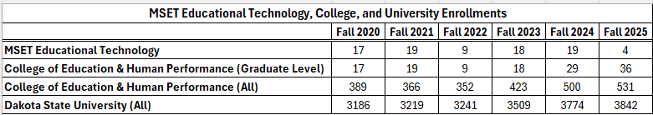

*Program Structure Note:
In 2024, the MSET Educational Technology program was revised, including a title change, addition of specializations, and CIP change (13 series to 11 series). This name change explains why the Fall 2024 and Fall 2025 data show fewer students enrolled in MSET than the total number of graduate-level enrollments. For example, in Fall 2024, 19 students were enrolled in the legacy program (MSET Educational Technology - no specializations) and 10 in the new program (MSET Education and Technology with 3 specializations).
Beginning Fall 2024, new students were admitted under the revised program. Legacy students may remain coded under the prior CIP through degree completion. Data are reported separately and reflect official program coding at the fall census.

MSET Education and Technology (New)
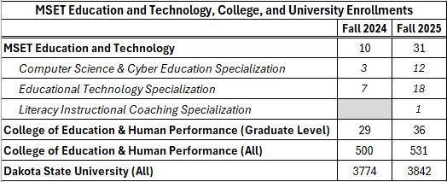

- Demographics (past six years):

MSET Educational Technology (Phasing Out)
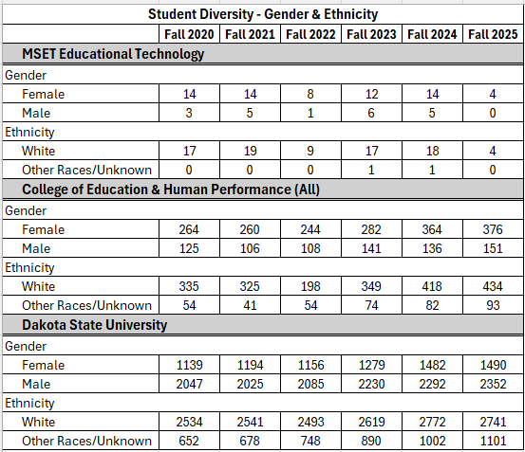

MSET Education and Technology (New)
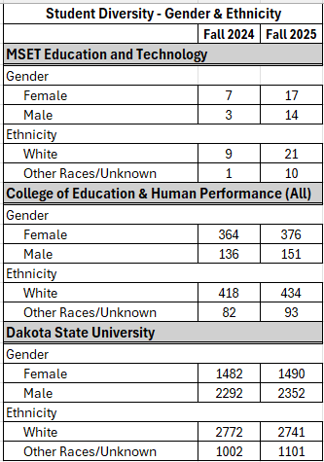

*Note: Other Races/Unknown includes all students who do not identify as 'White' based on ethnicity. This category includes students who identify as Hispanic/Latino as well as those classified as U.S. nonresidents.

- Application and acceptance rates (past six years):

MSET Educational Technology (Phasing Out)
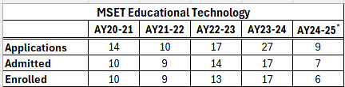

Note: Sometimes applications are started but then not completed. Therefore, not all applications that do not make it to admittance are rejected after review.

MSET Education and Technology (New)
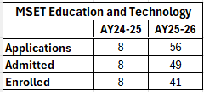

Note: Application funnel data are presented at the academic-year level to reflect the full scope of student demand and enrollment for the MSET Education and Technology program. Because this graduate program admits students across multiple terms (summer, fall, and spring), fall-only data would underrepresent activity. The ‘enrolled’ figures reflect new students from that year’s applicant pool and do not include continuing students, so they will differ from other tables that report total fall enrollment.

- Retention rates (past six years):

MSET Educational Technology (Phasing Out)
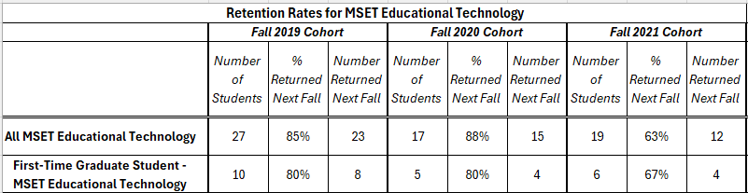

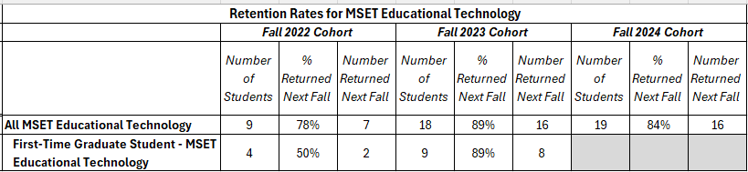
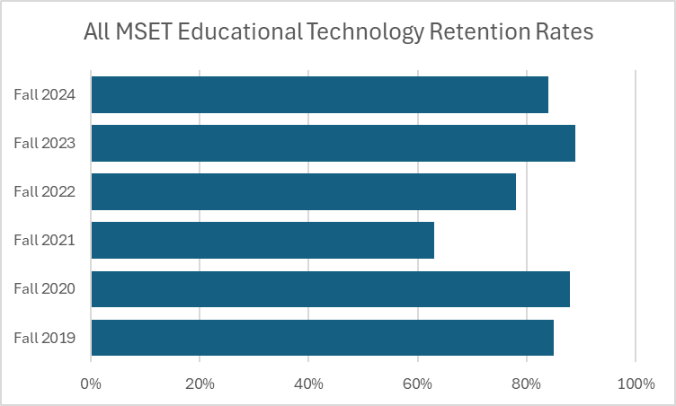

MSET Education and Technology (New)
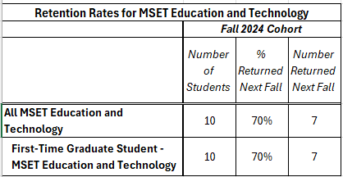

All MSET Educational Technology/MSET Education and Technology = All students enrolled in the MSET program for the specified fall cohort who returned the subsequent fall.

First-Time MSET Educational Technology/MSET Education and Technology = A subset of the All cohort, consisting of students designated as first-time graduate students in the specified fall cohort who returned the subsequent fall.

Note: First-Time students are included in the All MSET counts and should not be summed with the All totals.

- Number of Degrees Awarded (past six years):

MSET Educational Technology (Phasing Out)
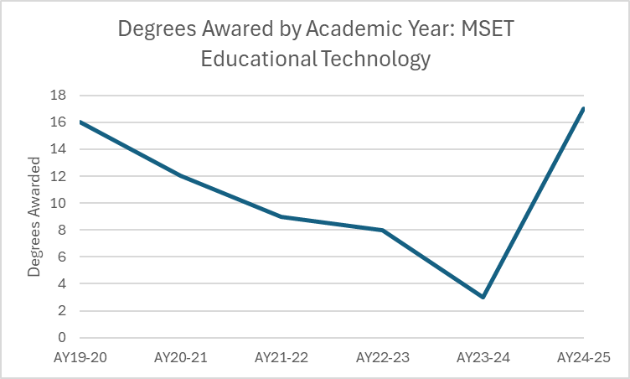

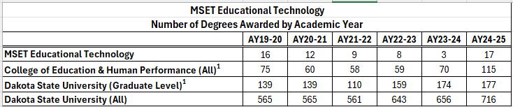

MSET Education and Technology (New)
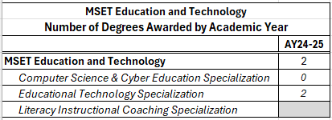

Note: Counts reflect degrees awarded. Students earning multiple degrees in the same academic year (i.e., BBA & BS or MS and certificate, etc.) are counted once per degree.
Note: The chart above shows students who graduated in AY24-25. They started by getting a degree in our former program, MSET Educational Technology, but then updated their catalogue year to the new degree, MSET Education and Technology. This explains why we have two students graduating with the new MSET Education and Technology degree, the first year it was offered.

MSET Education and Technology (New)

MSET Education and Technology Specialization Enrollment
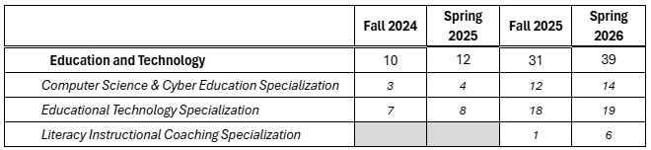
Section 6: Faculty Credentials

- Academic credentials for faculty who teach courses in the discipline (include vita as an appendix):

Current College of Education & Human Performance Faculty (Vitas in the appendix)

- Dr. Jennifer Nash, Ph.D., Associate Professor

- Dr. Katie Anderson, Ed.D, Assistant Professor

- Dr. Megan Schuh, Ed.D, Assistant Professor

- Dr. Kevin Smith, Ed.D, Associate Professor

- Academic credentials for faculty who teach support courses (include vita as an appendix):

- Tom Farrell, M.S., Adjunct Faculty Member

- Tina Boldt-Belden, M.S., Adjunct Faculty Member

- Dr. Betsy Schamber, Ed.D., Assistant Professor, Portfolio Reviewer

- Dr. Kindra Schneider, Ed.D, Assistant Professor, Portfolio Reviewer, Department Chair

- Summary of grant activity by faculty who teach in the program:

Dr. Jennifer Nash
- Faculty Research Initiative Award (Dakota State University), $5,000, 2024–2025 – Co-Principal Investigator, researching experiences of students in an online teacher apprenticeship program.

- South Dakota EPSCoR Track I Sub-award (National Science Foundation), approx. $10,000 annually, 2019–2023 – Mentor undergraduate education majors in developing STEM curriculum.

- South Dakota EPSCoR Sub-award (National Science Foundation), approx. $150,000 annually, 2014–2019 – Campus coordinator supporting STEM workforce development initiatives.

- Faculty Mini Innovation Grants (Dakota State University), 2016 and 2017 – Principal Investigator supporting STEAM education preparation.

- Interlakes United Way Education Project Grant (2012–2013) – Co-Principal Investigator focused on reading comprehension in science and social studies texts.

- South Dakota Department of Game, Fish & Parks “No Child Left Inside” Grant (2008).

Dr. Katie Anderson
- National Science Foundation EPSCoR Award (Implementation Team Member), $750,000 project, 2014–2019.

- National Network of State Teachers of the Year – ECET2 Conference (Bill & Melinda Gates Foundation), $22,000 in 2018 and $24,000 in 2019 (Convening Chair/Lead Executive Committee Member).

- South Dakota Department of Education State Personnel Development Grant Program (Higher Education Literacy Representative), $2.3 million program, 2018–2021.

- DSU Online Learning Academy Grant Participation, $500 (2020).

Dr. Kevin Smith
- National Science Foundation EPSCoR Award (Implementation Team Member / Co-PI), approx. $150,000 per year, 2014–2019.

- SD Space Grant Consortium Project Innovation Grant – Grant writing team member and workshop leader, $10,000 (2014).

- CenturyLink Teachers and Technology Grant – Grant writer, $1,500 (2014).

Dr. Kindra Schneider
- REM Grant for Professional Development surrounding best practice in assessment in SD (2023).

- Intermediary Teacher Apprenticeship Pathway Grant (2025)

- Phi Delta Kappa International (PDK) grant: Teacher Pathway Project: Creating Sustainable Pathway to Education Careers (2025)

- NSF South Dakota EPSCoR E-CORE Grant for SD (2025)

Dr. Betsy Schamber
- NSF STEM Education Grant, State of South Dakota.

- REM Grant for Professional Development (State of South Dakota) (2023).

- Summary of faculty and/or faculty-student research:

Dr. Jennifer Nash
- Schuh, M., Nash, J., Young, R., & De Jong, D. (In press, Winter 2025). A teacher apprenticeship pathway in a rural, Midwest state. AASA Journal of Scholarship and Practice.

- McKay, S., Geary, M., Maloney, J., Nash, J. & Geary, J. (2019). Rocket Roundup. In K. Graziano (Ed.), Proceedings of Society for Information Technology & Teacher Education International Conference (pp. 101-107). Las Vegas, NV, United States: Association for the Advancement of Computing in Education (AACE). Retrieved October 15, 2019 from https://www.learntechlib.org/primary/p/208488/

- J.M. Nash. Using Universal Design for Learning in Online Instruction. Online Classroom Newsletter 18(6): 2-3, 2018.

- J.M. Gross (Nash). Pre-service Teachers Learn to Teach Science Using Picture Books. South Dakota Reading Council Journal IV(1): 8-11, 2009.

- J.M. Gross (Nash) and D. Yee. Review Article: The type-1 IGF receptor tyrosine kinase and breast cancer: Biology and therapeutic relevance. Cancer Metastasis Review 22(4): 327-336, 2003.

- J.M. Gross (Nash) and D. Yee. How does the estrogen receptor work? Breast Cancer Research & Treatment 4(2): 62-64, 2002.

- Y. Wang, T.J. Berndt, J.M. Gross (Nash), M.A. Peterson, M.J. So, and F.G. Knox. Effect of inhibition of MAO and COMT on intrarenal dopamine and serotonin and on renal function. American Journal Physiology 280(1): R248-54, 2001.

- J.M. Gross (Nash), T.J. Berndt, and F.G. Knox. Effect of serotonin receptor antagonist infusion on phosphate excretion. Journal American Society Nephrology 11(6): 1002-7, 2000.

- A.C. Pflueger, T.S. Larson, K.A. Nath, B.F. King, J.M. Gross (Nash), and F.G. Knox. Role of adenosine in contrast media-induced acute renal failure in diabetes mellitus. Mayo Clinic Proceedings 75(12): 1275-83, 2000.

- J.M. Gross (Nash), J.E. Dwyer, and F.G. Knox. Natriuretic response to increased pressure is preserved with COX-2 inhibitors. Hypertension 34: 1163-1167, 1999.

- A.C. Pflueger, J.M. Gross (Nash), H. Osswald, and F.G. Knox. Adenosine-induced renal vasoconstriction in diabetes rats: role of prostaglandins. American Journal Physiology 277(46): R1410-R1417, 1999.

Dr. Katie Anderson
- Anderson, Katie, (2018). Understanding the Differences Between Novice and Experienced Reading Teachers. Walden Dissertations and Doctoral Studies. 5968. https://scholarworks.waldenu.edu/dissertations/5968

- Anderson, K., Sewell, W., & Munger, J. (2020). Report: Teacher Preparation in Reading in SD Regental Universities. SD Department of Education. Funded through SD SPDG Grant.

- Anderson, K., & Crowser, S (2021). State Adopted Professional Development for Teachers: Five-Day Foundational Reading Training for K-8th Grade Teachers. SD Department of Education.

- Anderson, K. (2023). Empowering Futures Through Literacy. The Dakota Scout. https://www.thedakotascout.com/p/viewpoint-empowering-futures-through

- Crowser, S., Anderson, K., Buechler, K., Zebill, D., Mueller, A., Newcomb, J., & Parce, E. (2023). SD Literacy Framework, Creating Effective Readers: Enabling Students to Be College, Career, and Life Ready. SD Department of Education. https://doe.sd.gov/literacy/Framework.aspx

- Klungseth, S., & Anderson, K. (2024). Teaching by Day, Moonlighting by Night: Moonlighting as a Response to Low Teacher Pay. American Journal of Education Research, 12 (2) 38-43. DOI:10.12691/education-12-2-2

Dr. Megan Schuh
- Schuh, M., Nash, J., Young, R., & De Jong, D. (Winter 2025). A teacher apprenticeship pathway in a rural, Midwest state. AASA Journal of Scholarship and Practice.

Dr. Kevin Smith
- Crandall, K., Noteboom, C., & Smith, K. D. (2025). Designing curiosity-driven AI chatbots for non-technical fields: A design science approach to supporting school counselors. In Proceedings of the International Association for Computer Information Systems.
- Bovee, B., Noteboom, C. B., Smith, K. D., & El-Gayar, O. (2024). Gamifying online discussions: A model for improving engagement using leaderboards. In AMCIS 2024 Proceedings. Association for Information Systems. https://aisel.aisnet.org/amcis2024/is_education/is_education/10

- Smith, K. D., & Klumper, D. (2018). Virtually in the classroom. Educational Leadership, 76(1), 60-65. Retrieved from http://www.ascd.org/publications/educational-leadership/sept18/vol76/num01/Virtually-in-the-Classroom.aspx

- Smith, K. D. (2018). Perceptions of preservice teachers about adaptive learning programs in K-8 mathematics education. Contemporary Educational Technology, 9(2), 111-130. Retrieved from https://www.cedtech.net/article/perceptions-of-preservice-teachers-about-adaptive-learning-programs-in-k-8-mathematics-education-6214

Dr. Betsy Schamber

- Grichko, V., Schamber, B., Termansen, K., Barker, D., Hall, S., Swank, D., & Lehmann, E. (2025). ERIC - EJ1462095 - Dissertation 2.0: An Action Research Study on Adapting with AI, Impacting Education: Journal on Transforming Professional Practice, 2025. Impacting Education: Journal on Transforming Professional Practice, 10(1), 33–41.

- Service to community/region provided by both faculty and students enrolled in the academic program:
Dr. Jennifer Nash
- State Accreditation Reporting: Contributed as a writer for the 2021 State Accreditation Report for the 5–12 Biology Education program.
- Educators Rising State Conference Presentation (2025): Co-presented “Teach Like a Pirate” with Dr. Megan Schuh and three DSU undergraduate students, providing professional development for aspiring educators.
- DSU Teach Camp Presentation (June 2024): Co-presented “Active Learning with Technology” during the virtual DSU Teach Camp. Participant survey results ranked this session among the top three sessions out of fifteen offered.
Dr. Katie Anderson
- South Dakota Department of Education Literacy Blueprint Steering Committee: Served during the 2024–2025 academic year on a statewide committee working with the SD Department of Education and the Board of Regents to develop literacy coursework for teachers.
- International Dyslexia Association – Upper Midwest Branch: Elected member of the Board of Directors. Responsibilities include promoting dyslexia awareness, supporting evidence-based literacy instruction, and advocating for improved identification and support for students with dyslexia.
- AIM Science of Reading Training (South Dakota): Collaborated with the South Dakota Department of Education to deliver statewide professional development. This initiative enabled 212 teachers to earn graduate credit through DSU.
- Foundational Reading Trainings: Led in-person summer professional development sessions for educators, resulting in 95 teachers earning graduate credit for certificate renewal.
- Sioux Falls School District Calendar Committee: Served as a parent representative collaborating with district administrators, teachers, and families to provide recommendations for future school calendars.
Dr. Megan Schuh
- Associated School Boards of South Dakota Conference Presentation: Presented on effective strategies for school administrators and board members to implement artificial intelligence in educational leadership contexts.
- Harrisburg Freshman Academy Outreach: Presented three sessions for prospective high school students, highlighting postsecondary opportunities in cybersecurity and computer science at DSU through interactive activities.
- Guest Speaker – University of Nebraska–Lincoln Doctoral Program: Provided guidance to doctoral students preparing for comprehensive exams and research proposal development.
- National Council for the Social Studies Membership: Active member utilizing research-based instructional resources to support teaching and course development in social studies education.
Dr. Kevin Smith
- Keynote Speaker – Lewis & Clark Literacy Council Annual Awards Night: Delivered keynote presentation for approximately 200 attendees, highlighting literacy initiatives and community engagement.
- K–12 Classroom Outreach: Visited 25 classrooms and 669 students, introducing students to Dakota State University while engaging them in literacy and mathematics activities.
- Chasing Einstein Mathematics Outreach Program: Implemented gamified mathematics learning activities with over 260 elementary students across several South Dakota schools.
- South Dakota Council of Teachers of Mathematics (SDCTM): Serves on the SDCTM Board as the National Council of Teachers of Mathematics representative.
- Multiplicity Lab Teacher Advisory Board: Appointed board member for Northwestern University’s Multiplicity Lab, supporting the development of research-informed mathematics teaching resources.
Dr. Betsy Schamber
- Parker School District Professional Development: Presented “Using AI in Your Classroom” during district in-service sessions for K–12 teachers.
- Peer Mentorship – University of South Dakota Adult and Higher Education Program: Served as a peer mentor for doctoral students, supporting research planning and academic progression.
- Conference and Professional Presentations:
  - School Administrators of South Dakota / Associated School Boards of South Dakota Convention: “Brains and Bots: Navigating the AI Revolution in K–12.”
  - South Dakota STEM Education Conference: “Using AI as Your EA: Using AI to Support You in Your Classroom.”
  - Educators Rising State Conference: “Unlocking Your Future: A Breakout EDU Session.”
  - Harrisburg Freshman Academy Showcase: “Breakout EDU: The Stolen Trophy.”
Dr. Kindra Schneider
- Dakota TESOL Board: Served as the Higher Education Representative on the Dakota TESOL Board, contributing to conference planning, professional resources, and organizational initiatives.
- K–12 Classroom Outreach: Delivered instructional lessons at Madison Elementary focused on feedback and learning strategies for fifth-grade students.
- Regional School Partnerships: Visited multiple classrooms in surrounding schools to provide literacy-focused read-alouds and instructional lessons.
- Teacher Support and Consultation: Worked with local educators to support the transition to standards-based grading systems and instructional improvement.
- Community Educational Outreach: Participated in community initiatives supporting student learning and literacy, including school and community events.

- Description of student organizations, etc., directly related to the academic programs being reviewed and particularly the impact those organizations have on student learning, etc.

The MSET program does not currently maintain a dedicated student organization. However, students are encouraged to engage with professional organizations and conferences related to educational technology and digital learning. These opportunities provide valuable avenues for networking, professional development, and exposure to emerging trends in the field.

Students are encouraged to participate in organizations such as the International Society for Technology in Education (ISTE) and to attend regional and state events, including the Technology and Innovation in Education (TIE) Conference and the South Dakota STEM Conference. Participation in these events allows students to connect with educators and technology leaders, explore innovative instructional practices, and learn about emerging technologies that influence teaching and learning.

Engagement with these professional communities supports student learning by helping students apply program concepts to real-world contexts, expand professional networks, and stay informed about current developments in educational technology.

- Anticipated changes in staffing because of retirements, program growth, etc.:

During the reporting period, the university implemented a revised administrative structure that changed how academic programs are managed. Newly established department chair positions now oversee both undergraduate and graduate programs within their departments. These roles replaced the previous model in which program coordinators were responsible only for graduate programs. The department chair structure provides greater alignment across undergraduate and graduate curricula and allows for more comprehensive program oversight. Department chairs also receive additional course release time to support responsibilities related to program leadership, coordination, and planning.

Another significant development during the reporting period was the addition of two new specializations within the MSET program: Computer Science and Cyber Education, and Literacy Instructional Coaching. The introduction of these specializations has increased instructional needs in certain areas. However, through collaboration with faculty across other colleges and departments at Dakota State University, the program has been able to draw on existing institutional expertise to support course delivery. These collaborations help ensure the program can meet instructional demands while maintaining the interdisciplinary perspective central to its goals.

At this time, the program can meet instructional needs through current faculty resources and cross-departmental collaboration. Future staffing needs will continue to be evaluated as enrollment patterns and specialization demand evolve.

Section 7: Academic and Financial Support

- Academic support provided to faculty and students:
For students, DSU provides academic advising, tutoring, and writing support. Trojan Tutoring is available free to all students in person and online. The Writing Center also supports students across disciplines with one-on-one help and workshops in reading, study skills, research, and scholarly formatting. DSU also provides disability services and counseling support that contribute to student persistence and academic success.
For faculty, DSU’s Center for Teaching and Learning (CTL) provides pedagogical support, instructional design and instructional technology consulting, new faculty orientation, and professional development programming. The CTL explicitly supports online teaching and offers individual, group, and departmental consultations. That is especially relevant for MSET because the program is delivered online and depends on sustained course design and online teaching quality.
- Library materials and training
DSU’s Karl E. Mundt Library supports academic programs through collections, information systems, staff expertise, online tutorials, and research aids. The library provides direct access to resources, growing e-book collections, scholarly databases, and interlibrary loan. It also identifies information literacy training as a core responsibility of the library, noting that students are trained to find, evaluate, and use information effectively.

- Technology Infrastructure
DSU has a strong university-wide technology infrastructure that supports online programs. Its online programs use D2L Brightspace as the learning management system, and DSU’s online program pages emphasize flexible online delivery with course materials, assignments, lecture notes, and exams available through the platform. The ITS support environment includes a centralized support desk, a knowledge base, and assistance for supported software, assigned hardware, and networking issues. For an online graduate program like MSET, this infrastructure is a significant institutional strength.

- Computer hardware and software
There is support for both hardware and software through Information Technology Services and the Support Desk/Repair Center. The Support Desk provides a single point of contact for supported software, assigned hardware, and networking issues, and the broader knowledge base includes D2L and online student help materials.

- The Office of Graduate Studies
The Office of Graduate Studies at Dakota State University has a coordinating, compliance, and support role in the function of each graduate program. Graduate Studies manages graduate application organization, review, and post-review communication. Once students are admitted to the program, they are assigned to a Graduate Enrollment Advisor. Enrollment advisors contribute to MSET student success by facilitating a smooth transition into graduate study. This includes onboarding support such as orientation to university organizations and processes, clarification of program requirements, and coordination with academic departments and faculty chairs/advisors.
The MSET program is one of 8-10 graduate programs or certificates that one enrollment advisor supports. The advisor guides the graduate student in developing a plan of study—the academic roadmap for each student. The advisor assists students through course substitutions, credit transfer, and other program documentation. When a plan for sequencing coursework is approved, the advisor tracks the students’ key academic milestones, and a mid-point progress conference is held with each student. The advisor will also assist the student with program hiatus (when necessary) and application to graduation.
This layer of student support is part of the overall role of Graduate Studies in ensuring graduate policies and requirements comply with Regental policies. Graduate Studies also administers graduate assistantships, promotes and assists in external funding development, and facilitates cross-program and interinstitutional collaboration.
The Office of Graduate Studies also works with program faculty to define a targeted marketing and recruitment strategy to support MSET enrollment, focusing on working professionals at the regional and national levels. Partnerships play a key role in recruitment and pipeline development, and Graduate Studies works to leverage collaborations with K-12 and higher education institutions, the SD state and national actors in teacher development and disciplinary associations to promote the program, identify qualified applicants, and support pathways to MSET graduate education.
The MSET program chair and the College of Education and Human Performance Dean serve on the Graduate Council, the governance body for DSU Graduate Programs. The Council, chaired by the Graduate Dean, is responsible for reviewing and recommending approval of graduate curriculum, including new programs, course proposals, and modifications to existing programs. The council also reviews and approves graduate faculty applications. In these roles, the Council ensures that graduate curricula remain aligned with institutional mission and academic standards.
- Support staff available for faculty and the college
  - Center for Teaching and Learning staff, including instructional design and educational technology support.
  - Library staff for research support, information literacy, and funding-resource support.
  - ITS and Support Desk staff for software, hardware, networking, and LMS support.
  - Records & Registration staff for registration, academic records, and course/classroom management support.
  - Professional Advisor works to provide both student and faculty support.
- Financial support available to the academic program, including revenue sources
Students may access assistance of federal student loans through the FAFSA application. The Office of Graduate Studies maintains a listing of graduate scholarship/fellowship information, and the Cashier can customize tuition payment plans for students in need. For MSET specifically, the 30-credit degree costs less than $15,000 in total tuition and fees, which supports affordability as part of the student financial support picture.
Also at the institutional level, graduate assistantships are one of the most common graduate funding sources of direct student support. The university also funds Graduate Research Initiative (GRI) awards annually to graduate students. In a competitive proposal process, graduate students can receive $500 towards their faculty-mentored research or process/product development idea. A similar program is available for graduate faculty (Faculty Research Initiative).
The following state revenue sources support academic programs: student-generated revenue (tuition, fees, auxiliaries, and grants) and general fund appropriations determined by the SD State Legislature. The report also notes the role of the DSU Foundation in maximizing resources for university programs. In addition, DSU’s sponsored-programs policy and pre-award manual show that external grants and contracts are another important funding stream for instructional, training, and research-related activities.
Grant funding has provided significant financial benefits to students enrolled in the MSET program by helping reduce the overall cost of coursework and specialized training opportunities. For example, grant support has subsidized elective experiences such as the DSU Cyber Camp for Teachers and DSU Teach Camp, allowing students to enroll at approximately $40 per credit, compared to the typical cost of about $480 per credit. These reduced-cost opportunities make high-quality professional development more accessible while enabling educators to gain hands-on experience with emerging technologies and innovative instructional practices.
MSET also includes two grant-funded specializations that further expand opportunities for students. One example is the Literacy Instructional Coaching specialization, supported beginning in Spring 2026 through funding from the South Dakota Department of Education (DOE). This grant addresses a statewide priority to strengthen literacy instruction through the Science of Reading and related evidence-based practices. Through this initiative, Dakota State University collaborates with South Dakota State University and the DOE to deliver an 18-credit graduate certificate in Literacy Instructional Coaching, which can be stacked into the MSET degree. Approximately 80 students are enrolled in this certificate/specialization. Grant funding helps support coursework and training that prepare educators to serve as literacy coaches who mentor teachers, implement research-based reading instruction, and support school-wide literacy improvement efforts. This partnership aligns graduate education with the state’s broader literacy initiatives while building a pipeline of educators capable of improving reading outcomes for South Dakota students.
Similarly, MSET offers a Computer Science & Cyber Education specialization that has received grant support to expand the pipeline of qualified K–12 educators prepared to teach computer science and cybersecurity. Approximately 14 students are enrolled in this certificate/specialization. This funding began in 2025 and supports educators who enroll in the 18-credit Computer Science and Cyber Education graduate certificate, which can be completed as a standalone credential or stacked into the MSET degree. The grant helps offset tuition and program costs for participating educators while supporting coursework aligned with South Dakota’s growing need for computer science and cybersecurity education. By preparing teachers to deliver these high-demand subjects locally—or through initiatives such as Dakota State University’s Governor’s Cyber Academy—the MSET program expands access to computer science learning opportunities across the state and strengthens the long-term pipeline of students entering technology and cybersecurity careers.
Section 8: Facilities and Equipment

- Facilities such as classrooms, laboratories, and other physical and/or technical facilities used to deliver the academic programs being reviewed:

This section is not applicable, as the program is delivered fully online. Equipment and technological resources available to faculty, including computer hardware, software, and supporting technology infrastructure, are described above in Section 7.

Section 9: Student Learning Assessment Plans and Results
- Program Learning Outcomes (PLOs) Statements:

  - Students will apply educational technology research findings to the formulation of educational technology research questions.
  - Students will produce a self-designed instructional learning module that includes learner/task analysis, measurable learning objectives, and instructional strategies and assessments aligned with the expected learning outcomes.
  - Students will present a classroom website portfolio that integrates reflections, course artifacts, and technology-enhanced design elements.

- Measures and Benchmarks Used for Each PLO:
  - Students will apply educational technology research findings to the formulation of educational technology research questions. Assessed in CET 785: Research Methods in Educational Technology
  - Students will produce a self-designed instructional learning module that includes learner/task analysis, measurable learning objectives, and instructional strategies and assessments aligned with the expected learning outcomes. Assessed in CET 712 - Instructional Design for Interactive Learning
  - Students will present a classroom website portfolio that integrates reflections, course artifacts, and technology-enhanced design elements. Assessed in CET 720 - Leadership & Evaluation of Educational Technology

- Program Learning Outcomes:

Program Learning Outcomes (PLOs) define the key knowledge, skills, and competencies that students are expected to demonstrate by the time they complete an academic program. They articulate clear expectations for student learning and reflect what faculty believe graduates of the program should know, be able to do, or value as a result of their studies. By measuring student performance relative to these outcomes, programs can evaluate how effectively students are achieving the intended learning goals and use the results to inform continuous improvement of curriculum and teaching practices.

Note: The PLOs below, based on grades within a course, were for the years 2019 through the summer of 2025. When a year’s data is missing, it means the course was not offered that year.
Final Grades for Courses Identified in the Program Learning Outcomes
CET 751 - Technology Hardware and Networking
Semester | # of Students | Overall GPA | % with “A” Grade | % with “B” Grade | % with “C” Grade | % with “D” Grade | % with “F” Grade
SU 2019 | 12 | 4.00 | 100.0% | 0.0% | 0.0% | 0.0% | 0.0%
SU 2021 | 11 | 4.00 | 100.0% | 0.0% | 0.0% | 0.0% | 0.0%
SU 2023 | 8 | 4.00 | 100.0% | 0.0% | 0.0% | 0.0% | 0.0%
SU 2025 | 15 | 3.93 | 93.3% | 6.7% | 0.0% | 0.0% | 0.0%

LT/CET 731 Multimedia Production
Semester | # of Students | Overall GPA | % with “A” Grade | % with “B” Grade | % with “C” Grade | % with “D” Grade | % with “F” Grade
SU 2019 | 18 | 4.00 | 100.0% | 0.0% | 0.0% | 0.0% | 0.0%
SU 2020 | 15 | 4.00 | 100.0% | 0.0% | 0.0% | 0.0% | 0.0%
SU 2021 | 10 | 4.00 | 100.0% | 0.0% | 0.0% | 0.0% | 0.0%
SU 2022 | 4 | 4.00 | 100.0% | 0.0% | 0.0% | 0.0% | 0.0%
SU 2023 | 14 | 4.00 | 100.0% | 0.0% | 0.0% | 0.0% | 0.0%
SU 2024 | 11 | 3.91 | 90.9% | 10.0% | 0.0% | 0.0% | 0.0%
SP 2025 | 13 | 3.77 | 84.6% | 7.7% | 7.7% | 0.0% | 0.0%

CET 756 – Introduction to Instructional Programming
Semester | # of Students | Overall GPA | % with “A” Grade | % with “B” Grade | % with “C” Grade | % with “D” Grade | % with “F” Grade
FA 2019 | 20 | 4.00 | 100.0% | 0.0% | 0.0% | 0.0% | 0.0%
FA 2020 | 15 | 4.00 | 100.0% | 0.0% | 0.0% | 0.0% | 0.0%
FA 2021 | 9 | 4.00 | 100.0% | 0.0% | 0.0% | 0.0% | 0.0%
FA 2022 | 6 | 4.00 | 100.0% | 0.0% | 0.0% | 0.0% | 0.0%
FA 2023 | 13 | 4.00 | 100.0% | 0.0% | 0.0% | 0.0% | 0.0%
FA 2024 | 17 | 3.83 | 88.2% | 5.9% | 5.9% | 0.0% | 0.0%

LT/CET 785 – Research Methods in Education Technology
Semester | # of Students | Overall GPA | % with “A” Grade | % with “B” Grade | % with “C” Grade | % with “D” Grade | % with “F” Grade
FA 2019 | 20 | 3.85 | 85.0% | 15.0% | 0.0% | 0.0% | 0.0%
FA 2020 | 9 | 4.00 | 100.0% | 0.0% | 0.0% | 0.0% | 0.0%
FA 2021 | 13 | 3.92 | 92.3% | 7.7% | 0.0% | 0.0% | 0.0%
FA 2022 | 6 | 4.00 | 100.0% | 0.0% | 0.0% | 0.0% | 0.0%
FA 2023 | 13 | 3.62 | 69.2% | 23.1% | 7.6% | 0.0% | 0.0%
FA 2024 | 12 | 4.00 | 100.0% | 0.0% | 0.0% | 0.0% | 0.0%

LT/CET 741 – Introduction to Distance Education
Semester | # of Students | Overall GPA | % with “A” Grade | % with “B” Grade | % with “C” Grade | % with “D” Grade | % with “F” Grade
SP 2020 | 14 | 3.79 | 78.6% | 21.4% | 0.0% | 0.0% | 0.0%
SP 2021 | 15 | 4.00 | 100.0% | 0.0% | 0.0% | 0.0% | 0.0%
SP 2022 | 10 | 4.00 | 100.0% | 0.0% | 0.0% | 0.0% | 0.0%
SP 2023 | 8 | 3.50 | 62.5% | 25.0% | 12.5% | 0.0% | 0.0%
SP 2024 | 20 | 3.80 | 95.0% | 0.0% | 0.0% | 0.0% | 5.0%
SP 2025 | 7 | 3.86 | 85.7% | 14.3% | 0.0% | 0.0% | 0.0%

CET 720 - Leading Evaluation and Change in Educational Technology Environment
Semester | # of Students | Overall GPA | % with “A” Grade | % with “B” Grade | % with “C” Grade | % with “D” Grade | % with “F” Grade
SP 2020 | 15 | 4.00 | 100.0% | 0.0% | 0.0% | 0.0% | 0.0%
SP 2021 | 8 | 3.88 | 87.5% | 0.0% | 12.5% | 0.0% | 0.0%
SP 2022 | 8 | 3.88 | 87.5% | 12.5% | 0.0% | 0.0% | 0.0%
SP 2023 | 8 | 4.00 | 100.0% | 0.0% | 0.0% | 0.0% | 0.0%
SP 2024 | 16 | 3.63 | 87.5% | 0.0% | 6.3% | 0.0% | 6.3%
SP 2025 | 16 | 3.81 | 81.3% | 18.8% | 0.0% | 0.0% | 0.0%
CET 723 – Inclusive STEM Instruction
Semester | # of Students | Overall GPA | % with “A” Grade | % with “B” Grade | % with “C” Grade | % with “D” Grade | % with “F” Grade
SP 2021 | 5 | 4.00 | 100.0% | 0.0% | 0.0% | 0.0% | 0.0%
SP 2022 | 5 | 3.60 | 60.0% | 40.0% | 0.0% | 0.0% | 0.0%
SP 2023 | 7 | 3.86 | 87.5% | 0.0% | 12.5% | 0.0% | 0.0%
SP 2024 | 4 | 3.75 | 75.0% | 25.0% | 0.0% | 0.0% | 0.0%
SP 2025 | 8 | 3.88 | 87.5% | 12.5% | 0.0% | 0.0% | 0.0%

CET 721 – Web Authoring
Semester | # of Students | Overall GPA | % with “A” Grade | % with “B” Grade | % with “C” Grade | % with “D” Grade | % with “F” Grade
SU 2020 | 8 | 3.75 | 75.0% | 25.0% | 0.0% | 0.0% | 0.0%
SU 2024 | 7 | 4.00 | 100.0% | 0.0% | 0.0% | 0.0% | 0.0%
SU 2025 | 2 | 2.00 | 50.0% | 0.0% | 0.0% | 0.0% | 50.0%

CET 753 – Network Management in Education Institutions
Semester | # of Students | Overall GPA | % with “A” Grade | % with “B” Grade | % with “C” Grade | % with “D” Grade | % with “F” Grade
SP 2020 | 11 | 4.00 | 100.0% | 0.0% | 0.0% | 0.0% | 0.0%
SP 2022 | 9 | 4.00 | 100.0% | 0.0% | 0.0% | 0.0% | 0.0%
SU 2024 | 14 | 4.00 | 100.0% | 0.0% | 0.0% | 0.0% | 0.0%

CET 725 - Educational Applications for Mobile Devices
Semester | # of Students | Overall GPA | % with “A” Grade | % with “B” Grade | % with “C” Grade | % with “D” Grade | % with “F” Grade
SP 2023 | 4 | 3.75 | 75.0% | 25.0% | 0.0% | 0.0% | 0.0%
SP 2024 | 7 | 3.86 | 85.7% | 14.3% | 0.0% | 0.0% | 0.0%
SP 2025 | 6 | 4.00 | 100.0% | 0.0% | 0.0% | 0.0% | 0.0%

PLOs were previously measured primarily through overall course grades. However, after review, the faculty determined that relying solely on course grades did not provide sufficient detail to guide meaningful program improvements. To better identify specific areas where students demonstrate strengths or face challenges, the program shifted to evaluating targeted assessments within core courses. This approach allows faculty to analyze student performance on key assignments and gather more precise data to inform programmatic decisions. As a result, the following PLOs were implemented beginning in Fall 2025:

- Current Educational Research: Students will apply educational technology research findings to the formulation of educational technology research questions. (CET 785: Research Methods in Educational Technology)

- Teaching: Process and Practices: Students will produce a self-designed instructional learning module that includes learner/task analysis, measurable learning objectives, and instructional strategies and assessments aligned with the expected learning outcomes. (CET 712 - Instructional Design for Interactive Learning)

- Capstone Portfolio Project: Students will present a classroom website portfolio that integrates reflections, course artifacts, and technology-enhanced design elements. (CET 720 - Leadership & Evaluation of Educational Technology)

Program Learning Outcomes (PLOs) Fall 2025

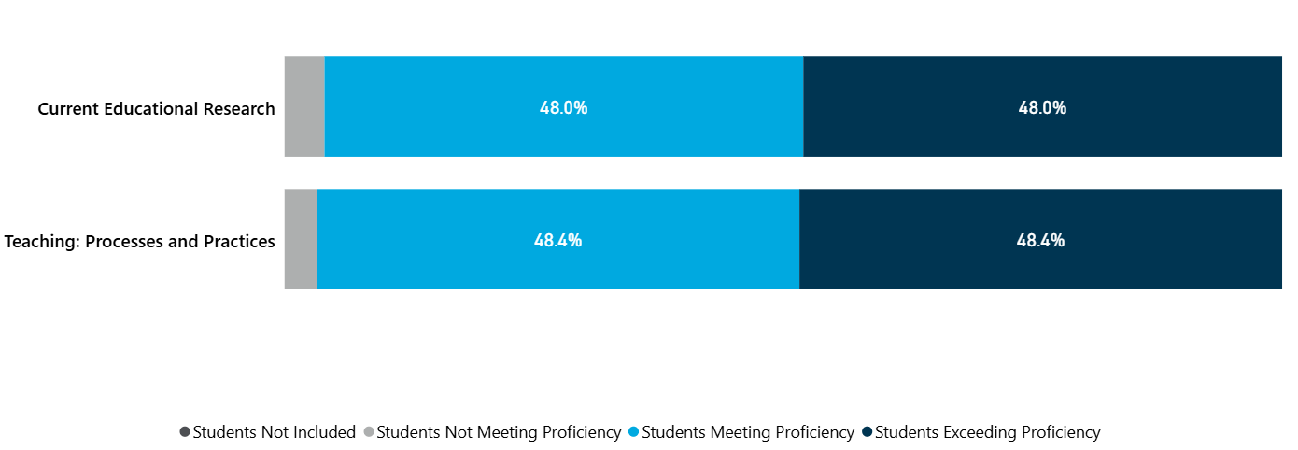
Note: In the graph above, the light grey represents one student who wasn’t proficient in each course. The light blue represents students who were proficient. The dark blue represents students who exceeded proficiency.
Current Educational Research: The one student who did not reach proficiency simply failed to complete the project.
Teaching: Processes and Practices: The one student who failed to meet proficiency was unable to develop content and instructional strategies for implementing and evaluating technology.

Note: The CET 720 course has not yet been completed under this assessment structure; therefore, data for the Capstone Portfolio Project PLO are not included in the chart above.
MSET Major Assessment:
Master’s of Science in Educational Technology
MSET Exit Portfolio: Requirements for 2019 - 2024

The MSET Exit Portfolio serves as the program’s culminating assessment and final student project. Students develop a web-based professional portfolio that documents their growth and competency across the program while reflecting on how coursework and project experiences have influenced their professional practice. The portfolio typically includes a professional introduction, a statement of philosophy regarding the role of technology in teaching and learning, thematic connections to program objectives, and selected artifacts demonstrating applied learning from coursework. Students present their portfolios in a 20–30 minute review session with a faculty panel, highlighting key accomplishments and professional applications of educational technology, followed by a question-and-answer period. Portfolio development begins early in the program, with a mid-program Plan of Study review to support artifact collection and alignment with program outcomes. The portfolio functions both as an authentic assessment of student learning and as a professional tool graduates may use to communicate their expertise to employers. Aggregated portfolio outcomes also provide the program with an important source of evidence for evaluating program quality and continuous improvement.

Master’s of Science in Education and Technology
Capstone Course: Requirements for 2025 moving forward

The program’s culminating assessment occurs within CET 720 – Leading Evaluation and Change in the Educational Technology Environment, where students complete a capstone portfolio project. In this course, students develop a web-based site that highlights their applications of educational technology and demonstrates their learning spanning their entire program. The website includes a professional introduction, a statement of philosophy regarding the role of technology in teaching and learning, and selected artifacts that illustrate their implementation of educational technology concepts and practices explored in the course. As the final component of the capstone experience, students deliver a presentation of their website to a faculty review panel, highlighting their learning, implementation strategies, and key accomplishments. The presentation is followed by questions from the panel, providing an opportunity for students to articulate their understanding of educational technology leadership and change within educational environments.

Section 10: Alumni Placement & Satisfaction

- Employment placement information for graduates since the last review:

MASTER OF SCIENCE IN EDUCATIONAL TECHNOLOGY
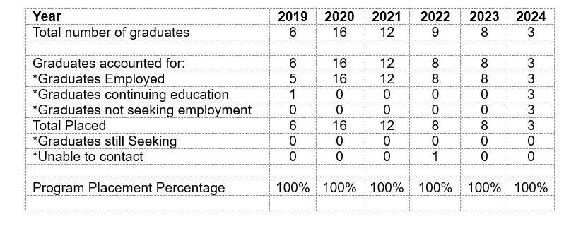

Section 11: Program Opportunities for Improvement

Historically, the MSET program has not maintained a consistent process for gathering graduate satisfaction and outcomes data aligned to current Program Learning Outcomes (PLOs). Moving forward, the program will implement an ongoing graduate satisfaction survey designed to directly assess PLO alignment, program effectiveness, and areas for continuous improvement. This process will support more intentional data-informed decision-making, ensure alignment with evolving program goals, and provide a sustainable mechanism for monitoring graduate experiences and outcomes over time.

Appendix A: Student Plan of Study

Core Courses (12 credits)
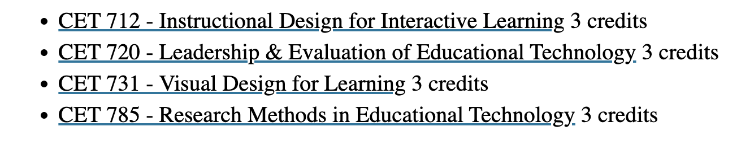
Computer Science and Cyber Education Specialization (18 credits)
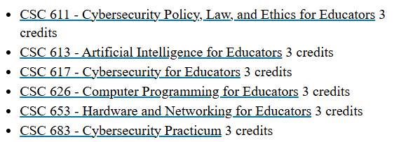

Educational Technology Specialization (18 credits)
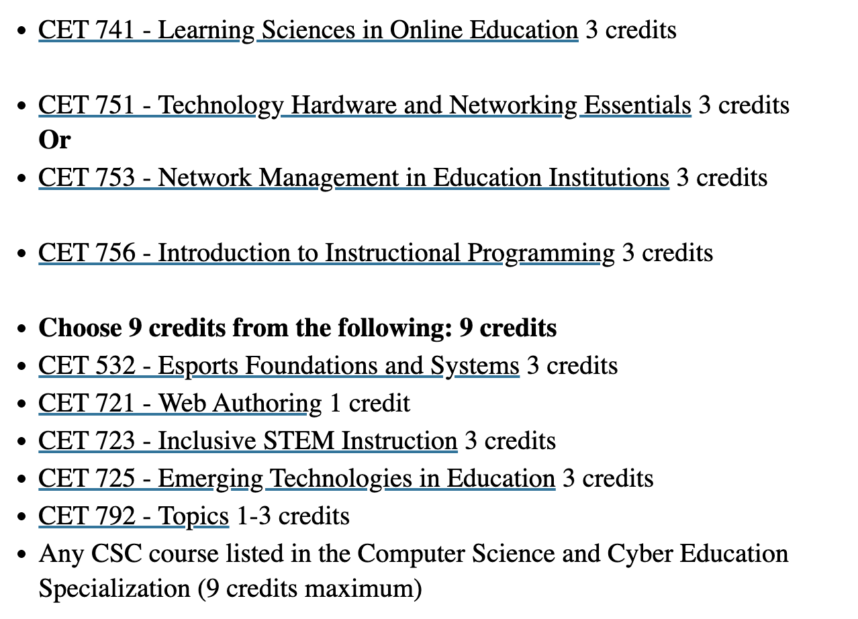

Literacy Instructional Coaching Specialization (18 credits)
