 | SOUTH DAKOTA BOARD OF REGENTS  ACADEMIC AFFAIRS FORMS
 | Accelerated Graduate Program Request

Use this form to request an accelerated graduate program and the appropriate required codes from the Enrollment Services Center. After the university President approves the proposal, submit a signed copy to the Executive Director through the system Chief Academic Officer.

UNIVERSITY: | DSU
NAME AND DEGREE (e.g., BA, BS) OF UNDERGRADUATE PROGRAM: | BS General Studies
NAME AND DEGREE (e.g., MA, MS, PhD) OF GRADUATE PROGRAM: | MSEd, Education and Technology

University Approval
To the Board of Regents and the Executive Director: I certify that I have read this proposal, that I believe it to be accurate, and that it has been evaluated and approved as provided by university policy.

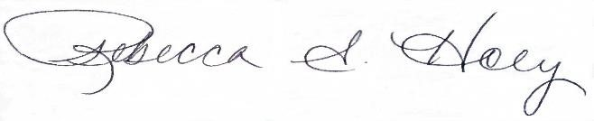 |  | 4/1/2025
Vice President of Academic Affairs or President of the University |  | Date

An accelerated graduate program for the purposes of this guideline is a graduate program at a Regental institution that allows a student to count courses for undergraduate and graduate credit simultaneously. Board Policy 2.4.2 – Course Level, Numbering, and Enrollment in Courses governs the transfer of courses between the undergraduate and graduate program.

Board of Regents Policy 2.2.2.1 – Seamless Transfer of Credit requires the Board of Regents to approve accelerated programs involving the transfer of thirteen (13) or more credits up to a total of twenty-five (25) total transfer credit hours at the accepting institution. In other words, an institution may create an accelerated program of one (1) to twelve (12) hours without Board approval. However, an accelerated program requires the creation of coding by the Enrollment Services Center (ESC) regardless of whether or not the accelerated program is accepting more than twelve (12) credit hours.

- Maximum number of credits allowed to transfer between undergraduate and graduate program:

Existing Curriculum  BS in General Studies |  |  |  |  | Proposed Curriculum  MSEd Education and Technology
Pref. | Num. | Title | Cr.  Hrs. |  |  | Pref. | Num. | Title | Cr. Hrs.
 |  | Elective Course | 3 |  |  | Students may take MSET graduate courses except: Capstone and Research. Students will work with their advisors on course selection. |  |  | 12
 |  | Elective Course | 3
 |  | Elective Course | 3
 |  | Elective Course | 3

- Is the response to Question 1 more than thirteen (13) credit hours?

Yes ☐  (requires BOR approval) | No ☒  (does not require BOR approval)

- What is the proposed date (day/month/year) the accelerated program would begin?

Fall 2026

- Please provide a brief explanation of the accelerated program, including specific courses eligible for both the undergraduate and graduate program credit.

This proposed accelerated program will give upper-level students the flexibility to apply elective coursework toward completion of the MSEd in Education and Technology degree.

