 | SOUTH DAKOTA BOARD OF REGENTS  ACADEMIC AFFAIRS FORMS
 | Minor Program Modification

Use this form to request minor changes in existing programs (majors, minors, certificates, or specializations). The university Vice President for Academic Affairs approves minor program modifications and they are included in the Annual Minor Program Modification Summary form.

UNIVERSITY: | DSU
PROGRAM TITLE: | Master of Science Information Systems
CIP CODE:
UNIVERSITY DEPARTMENT: | Information Systems
BANNER DEPARTMENT CODE: | DINFS
UNIVERSITY DIVISION: | College of BIS
BANNER DIVISION CODE: | DBIS

University Approval
To the Board of Regents and the Executive Director: I certify that I have read this proposal, that I believe it to be accurate, and that it has been evaluated and approved as provided by university policy.
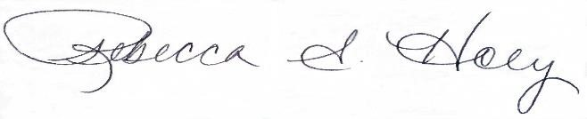 |  | 10/28/2025
Vice President of Academic Affairs or President of the University |  | Date

- This modification addresses a change in (place an “X” in the appropriate box):

☒ | Course deletions that do not change the nature of the program, or distribution of courses in the program, or change of total credit hours required | ☒ | Course additions that do not change the nature of the program, or distribution of courses in the program, or change of total credit hours required
☒ | Revised courses in the program.

- Effective date of change: 5/19/2026

- Program Degree Level (place an “X” in the appropriate box):

Associate | ☐ | Bachelor’s | ☐ | Master’s | ☒ | Doctoral | ☐

- Category (place an “X” in the appropriate box):

Certificate | ☐ | Specialization | ☒ | Minor | ☐ | Major | ☐

- Is the program associated with a current articulation agreement?
Yes |  | ☐ | No | ☒
  - If yes, will the articulation agreement need to be updated with the partner institution as a result of this minor program modification? Why or why not?

- Primary Aspects of the Modification (add lines or adjust cell size as needed):

Table 1
Health Information Systems Specialization

Current Courses Proposed Change:
HIMS 701 Foundations in Health Information | 3 credits | HIMS 701 Foundations in Health Information | 3 credits
HIMS 702 Foundations in Health Information Classification Systems | 3 credits
 |  | HIMS 746 Data Governance | 3 credits
HIMS 745 Cyber Ethics | 3 credits | HIMS 745 Cyber Ethics | 3 credits

- Explanation of the Change:

HIMS 702 frequently has low enrollment, so a portion of the course is being incorporated into HIMS 701. HIMS 702 will no longer be available for this specialization and is being replaced with a relevant course for the HIS specialization. HIMS 746 covers governance of IT as well as information governance, AI governance, and data governance.

