 | SOUTH DAKOTA BOARD OF REGENTS  ACADEMIC AFFAIRS FORMS
 | Minor Program Modification

Use this form to request minor changes in existing programs (majors, minors, certificates, or specializations). The university Vice President for Academic Affairs approves minor program modifications and they are included in the Annual Minor Program Modification Summary form.

UNIVERSITY: | DSU
PROGRAM TITLE: | Master of Business Administration (MBA), Analytics Emphasis
CIP CODE:
UNIVERSITY DEPARTMENT: | Business
BANNER DEPARTMENT CODE: | DBUSS
UNIVERSITY DIVISION: | College of BIS
BANNER DIVISION CODE: | DBIS

University Approval
To the Board of Regents and the Executive Director: I certify that I have read this proposal, that I believe it to be accurate, and that it has been evaluated and approved as provided by university policy.
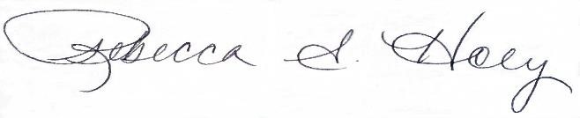 |  | 10/28/2025
Vice President of Academic Affairs or President of the University |  | Date

- This modification addresses a change in (place an “X” in the appropriate box):

☒ | Course deletions that do not change the nature of the program, or distribution of courses in the program, or change of total credit hours required | ☐ | Course additions that do not change the nature of the program, or distribution of courses in the program, or change of total credit hours required
☐ | Revised courses in the program.

- Effective date of change: 5/19/2026

- Program Degree Level (place an “X” in the appropriate box):

Associate | ☐ | Bachelor’s | ☐ | Master’s | ☒ | Doctoral | ☐

- Category (place an “X” in the appropriate box):

Certificate | ☐ | Specialization | ☒ | Minor | ☐ | Major | ☐

- Is the program associated with a current articulation agreement?
Yes |  | ☐ | No | ☒
  - If yes, will the articulation agreement need to be updated with the partner institution as a result of this minor program modification? Why or why not?

- Primary Aspects of the Modification (add lines or adjust cell size as needed):

Analytics Emphasis (Choose 2 courses):

Current Courses Proposed Change:
INFS 768 - Predictive Analytics for Decision Making | 3 credits | INFS 768 - Predictive Analytics for Decision Making | 3 credits
INFS 776 - Business Intelligence and Visualization | 3 credits | INFS 776 - Business Intelligence and Visualization | 3 credits
INFS 782 - Marketing Analytics | 3 credits

- Explanation of the Change: This change removes INFS 782 Marketing Analytics from the list of choices for the analytics emphasis in the MBA program. This course has had no enrollment and has not been offered. There are two choices remaining to meet the requirement for two courses which will help to manage and optimize course selection.

