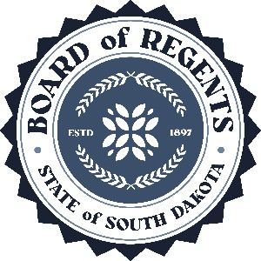 | SOUTH DAKOTA BOARD OF REGENTS  ACADEMIC AFFAIRS FORMS
Program Termination or
Placement on Inactive Status

Use this form to request termination or inactive status for an existing program (graduate program, undergraduate major or minor, certificate, or specialization). The Board of Regents, Executive Director, and/or their designees may request additional information about the proposal. After the university President approves the proposal, submit a signed copy to the Executive Director through the system Chief Academic Officer. Only post the form to the university website for review by other universities after approval by the Executive Director and Chief Academic Officer.

UNIVERSITY: | DSU
DEGREE(S) AND PROGRAM: | Center of Excellence Minor
CIP CODE: | 11.0401
UNIVERSITY DEPARTMENT: | College of Business & Information Systems
BANNER DEPARTMENT CODE: | DCBIS
UNIVERSITY DIVISION: | Information Systems
BANNER DIVISION CODE: | DINFS

University Approval
To the Board of Regents and the Executive Director: I certify that I have read this proposal, that I believe it to be accurate, and that it has been evaluated and approved as provided by university policy.
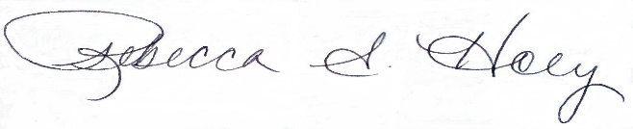 |  | 2/18/2025
President of the University |  | Date

- Program Degree Level (place an “X” in the appropriate box):

Associate | ☐ | Bachelor’s | ☐ | Master’s | ☐ | Doctoral | ☐

- Category (place an “X” in the appropriate box):

Certificate | ☐ | Specialization | ☐ | Minor | ☒ | Major | ☐

- The program action proposed is (place an “X” in the appropriate box):
Inactive Status | ☐ | Termination | ☒
See question 4 |  | See questions 5 and 6

- TERMINATION WITH ENROLLED STUDENTS

  - Provide a justification for terminating the program:

The Center of Excellence minor was part of the Center of Excellence in Information Systems, and the direction of the Center is now being realigned so the minor will be terminated.

  - What is the plan for completion of the program by current students?

Current students will be notified of the plans to terminate the minor and advised about scheduling courses to ensure that they register in a timely manner.

  - What is the proposed date (day/month/year) program termination status begins (program status in the database changes to Phasing Out and last date a student may enroll in or declare the program)?

Recruitment and promotion of the minor will end in Spring 2025 and the minor will not be approved for students to add or declare the minor beginning in Summer 2025

  - What is the last date (day/month/year) in which a student may enroll in the program (program status in the database changes to Phase Out)?

Summer 2025

  - What is the last term or date (day/month/year) by which a student can graduate from the program?

Fall 2029

  - What are the potential cost savings of terminating the program and what are the planned uses of the savings?

There would be no cost savings because of the termination.

  - What are the resulting employee terminations and other possible implications including impact on other programs?

None

Note: Certificates, specializations, and minors may only be terminated and not placed on inactive status due to limitations in the student information system.
Note: An inactive program is a program a university has authority to offer, but the program is not admitting new students and has not formally terminated. A presumption exists that inactive status is a temporary status; universities review inactive programs periodically to determine the feasibility of reactivating or terminating the program. Programs can remain inactive for five (5) consecutive years at which time a university must terminate the program. A terminated program is a program for which a university ceases to have authority to offer. Reinstatement of a terminated program requires university and BOR approval through the prescribed new program approval processes.

