To create an accessible syllabus in Word and save it as a PDF:

* Use the Check Accessibility option in Word to ensure there are no accessibility errors. On the **Review** tab, click the **Check Accessibility** button:  
  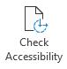
* Fix all issues reported by the Check Accessibility tool
* Click **File** à **Info**
* In the **Properties** pane, click the **Add a title** link to the right of **Title**  
  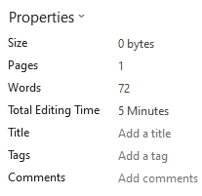
* Add a descriptive title.  
  A title of Syllabus Example
* Press **Enter** and then press **Esc**
* Click **File** à **Save As**
* Click the **More options…** link (above the **New Folder** button)
* Change the **Document type** to **PDF**
* Click the **Options…** button
* Ensure that **Document properties** and **Document structure tags for accessibility** options are checked:  
  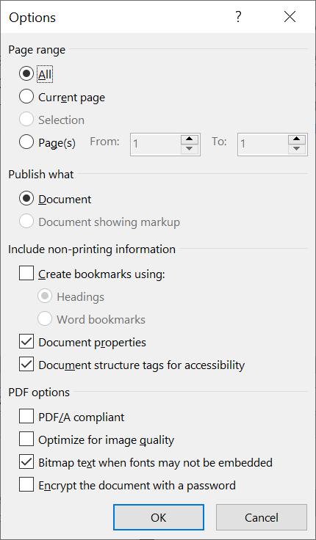
* Click **OK**
* Click **Save**